

Delta Kappa Gamma International Society Carroll County Chapter





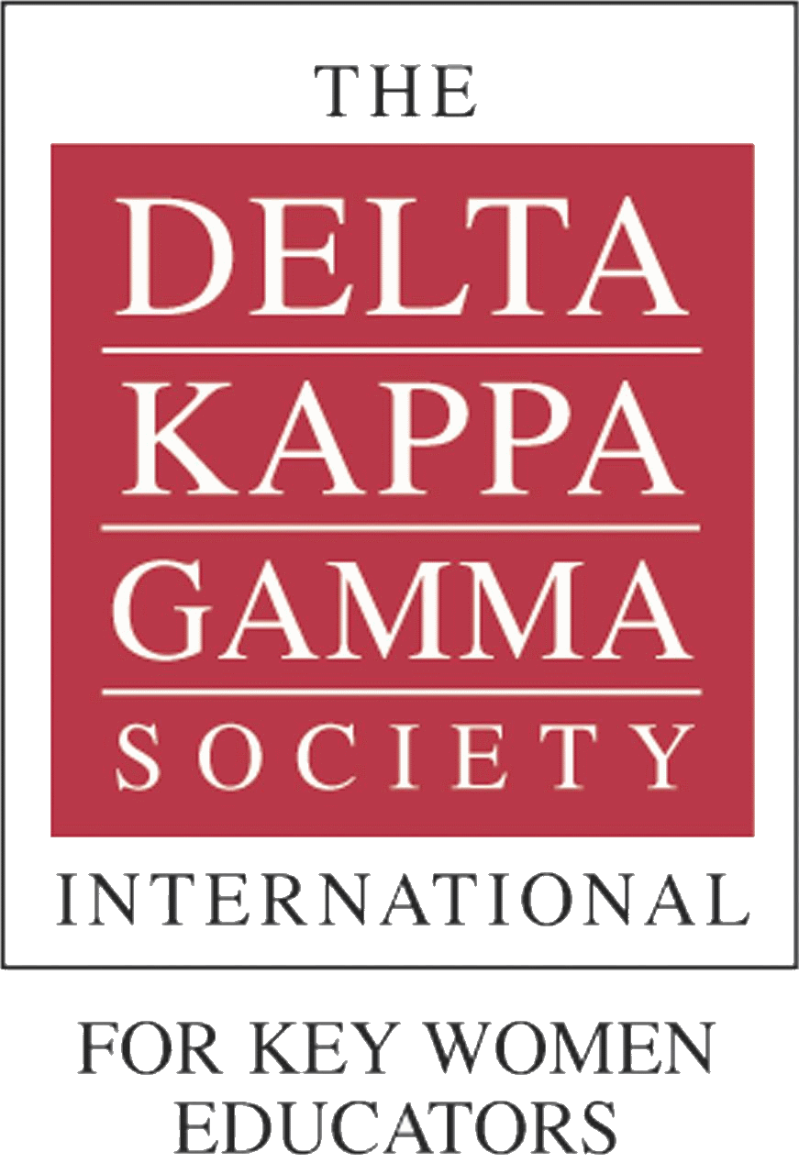

E-mail: Omicrondkgmd@gmail.com

Email for more information on how to become a member

*The Delta Kappa Gamma Society International is an honorary society with over 100,000 members in seventeen countries. The Omicron Chapter of Alpha Beta State is located in Carroll County, Maryland.*

Promoting professional and personal growth of its members and excellence in education

**1. To UNITE women educators of the world in a genuine spiritual fellowship  
2. To HONOR women who have given or who evidence a potential for distinctive service in any field of education  
3. To ADVANCE the professional interest and position of women in education  
4. To INITIATE, ENDORSE and SUPPORT desirable legislation or other suitable endeavors in the interests of education and of women educators  
5. To ENDOW scholarships to aid outstanding women educators in pursuing graduate study and to grant fellowships to non-member women educators  
6. To STIMULATE the personal and professional growth of members and to encourage their participation in appropriate programs of action   
7. To INFORM the members of current economic, social, political and educational issues so that they may participate effectively in a world society**



You have been selected to receive information about DKG because...

**You are open to change**

DKG encourages its members to explore new experiences and challenges

**You want to be empowered**

DKG provides the resources you need to reach your personal and professional goals. Your DKG membership will entitle you to all the benefits of the Society such as scholarships for furthering your education, grants to purchase resources for your classroom, leadership training and courses, and much more

**You draw inspiration from others**

DKG will connect you with phenomenal women who will share their personal and professional experiences. DKG provides numerous opportunities for you to network with other women in education through conferences, conventions, and local and regional meetings

Established in 1960, Omicron Chapter is 60+ members strong. Our members include teachers, administrators and supervisors from all parts of the county. Our goal of promoting the professional and personal growth of our members extends into the schools and the community.

Our chapter…

Discusses current local and national educational issues

Addresses women’s physical and mental health issues

Encourages fellowship and networking among master educators

Provides Personal Growth Grant opportunities

Offers leadership possibilities on local and state levels

Sponsors a college scholarship for a female Carroll County graduate in the education field

Organizes local cultural trips

Supports The Shepherd’s Staff

Supports The Carroll County Arts Council

Omicron Chapter of DKG Carroll County



The Delta Kappa Gamma Society was founded on May 11, 1929, at The University of Texas in Austin, Texas, by Dr. Annie Webb Blanton. Dr. Blanton conceived the idea of an organization for women educators. The founding group of twelve women educators represented a cross-section of the teaching profession. There were a grade school teacher, a dean of women, three high school teachers, three elementary school principals, and four college professors. The first chapter, Alpha Chapter, was installed on June 3, 1929.

     The Founders believed that there was need of an organization in which women educators might be united for efforts toward better professional preparation, recognition of women's work in the teaching profession, and scholarships for those needing aid in improving their professional preparation.

History of The Delta Kappa Gamma Society International