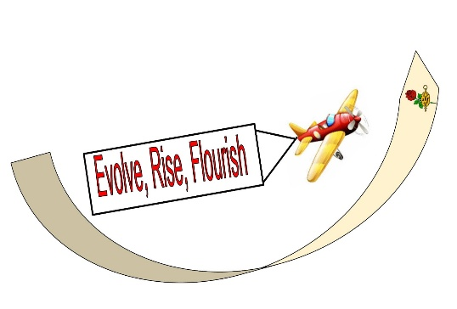

DKG Maryland State Organization
Virtual Workshop

Saturday, November 6, 2021
8:30 am – 12:30 pm

Agenda
Evolve, Rise, Flourish

8:30 – 8:55 Zoom Sign In
Music by Betty Hepler, Omega,
Music Committee

9:00 –9:15 Welcome and Opening Remarks:
Dr. Marilyn Keane, President, Upsilon
Pledge of Allegiance: Patty Simon, Mu
Overview of the Day:
Sally Nazelrod, First Vice President, Xi

9:15-10:00 Membership Enlightenment
Sharon Darling, Nu, Membership Chair

10:00-10:45 Leveling the Playing Field for All Children
Maryland State Senator JoAnne C. Benson, Theta

10:45-10:55 Break and Assignment to Break-Out Rooms
10:55-11:40 Break-Out Session Workshops – Select 1 of the 3

- DKG Maryland Website Overview
Dr. Minnie Young, Webmaster, Eta

- Traveling away from Dementia:
Make Your Retirement an Adventure
John Sisson, MRSPA Travel Committee

3. Current Teachers: Sharing Stories: Successes and Challenges
Facilitator: Erin Myers, Pi

11:40-12:25 Sharing Chapter Success:
Member Support, Community Service, and Educational Partnerships
Iris Wingert, Omicron

12:25 Closing Remarks: Dr. Marilyn Keane
Evaluation/Announcements
DKG Song

Delta Kappa Gamma Song
Annie Webb Blanton & Cora M. Martin

Women teachers to the calling
Firmly rally, never falling
Duty ne’er upon us palling,
Staunch, courageous we!
Loyalty and trust e’er heeding
Mindful of our sisters needing,
Aid and guidance from those leading,
Helpful may we be!

To Delta Kappa Gamma
Faith we pledge forever!
Hand in hand our loyal band,
Forward moving ever!
Onward! ‘Tis our sisters need us!
Courage, Faith, and Honor lead us!
Wrongs in truth and justice heed us!
Firmly shall we stand!

Guardians of the faith yet sleeping
For our sisters watch e’er keeping
Deeds of others now we’re reaping,
We for others stand!
To us pioneers have given;
We return their gifts to heaven;
Work for others is the leaven
That inspires our band!

Oh, Delta Kappa Gamma
In thy fold we gather!
Unity and Liberty,
Shall be our watchwords ever!
Education e’er we’ll further;
Each is bound to each as brother;
With this faith in one another
We shall win for aye!

Educational Excellence Committee 2021-2023
Sally Nazelrod, Xi
Dr. Terri Showers, Lambda
Dr. Annette Blake, Theta
Bonnie Brose, Theta
Patty Simon, Mu
Karen Yancey, Omega

We appreciate you for supporting this program and appreciate your
feedback to Sally4280@aol.com

We wish you a wonderful Thanksgiving!

