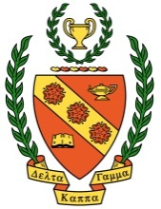
Omicron News
Omicron Chapter, Alpha Beta State
Delta Kappa Gamma Society International
Established June 14, 1960

Vol. 59, No. 2 _ Spring 2019

Message from the President

Greetings Omicron Sisters,
Our Omicron Chapter is off to a wonderful start to this new biennium with two great events under our belt including a fanciful Halloween program featuring pumpkin carver Frank Reaver and a fabulous dinner hosted by Blue Bistro of Westminster. Please mark your calendars for our remaining four meeting dates: Tuesday, February 19, Thursday, March 21, Tuesday, April 16, and Wednesday, May 8th. Our meetings are no fun without YOU, so please attend as many as you can.
Our chapter’s illustrious executive board members held a very productive meeting on January 16. We reviewed our entry for the Alpha Beta State (ABS) Chapter Achievement Award and the nominees for the ABS Community Service Award. At our February meeting, you will have the opportunity to decide which of the six members will receive the ABS Black-Eyed Susan Award, and believe me, it’s a very difficult decision to make. Additionally, two new initiatives emerged from our executive board meeting. The first is to host a chapter yard sale to keep our budget solvent and healthy into the next biennium (please see the article written by Cindi King who is heading up that initiative). The second project is to assemble a basket of goodies to be auctioned off at the Alpha Beta State Convention in April. Laurette O’Keefe has graciously offered to oversee that project and has included an article about that venture in this newsletter as well. Our Taneytown Elementary School partnership is going strong. In this newsletter, you will find an article written by Laura McClelland with details about upcoming plans for that project. Additionally, there are several attachments included with this newsletter. If you have any problems opening them, email me and I will send them to you separately.
Finally, I have some questions for you: Are you willing to participate in professional experiments? Are you loyal to your administration? Are you open-minded, have tact, poise, emotional stability, perception, initiative and enthusiasm? If you are all these things, then you could qualify to be a member of Delta Kappa Gamma, but only if you have been teaching for five years or more. (Ha ha!) This is all according to the membership requirements in the DKG handbook of 1972. If you find these criteria as intriguing as I do, then you won’t want to miss reading the special and fascinating article written by Althea Miller about her recollections of the Omicron chapter in the mid 1960’s.
Here’s hoping that Phil, the groundhog’s, predictions are accurate and that we get an early spring.
Take care and be well,
Iris

Omicron News Page 2 Spring 2019
February’s Program Meeting
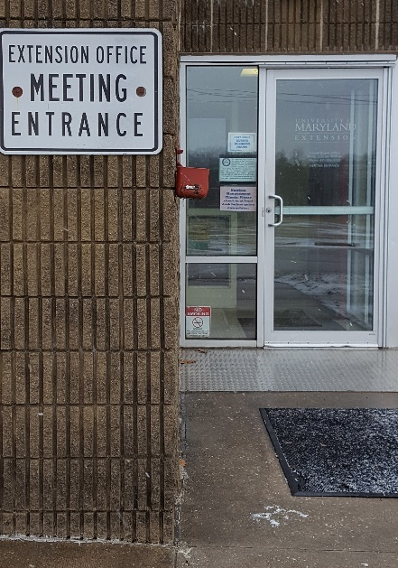
Want a cure for your cabin fever? Attend our next chapter meeting: February 19 at 6:00 p.m. at the University of Maryland Extension Office; 700 Agriculture Center Drive; Westminster
Want to stick to your healthy New Year’s resolution? February’s program is about selecting healthy foods to eat when you choose to eat out. Our speaker will also give us a cooking demonstration by converting an unhealthy restaurant selection into one that you can make at home and enjoy the benefits of good nutrition. Taste-testing will be available as well.
Looking for a great way to get warm? Feel warm all over by donating New / Never Used: Twin Blankets, Extra Long Single/Twin Sheets and Towels to the Westminster Women’s Shelter - - our community service focus for February. And enjoy the warmth of friendship from your Omicron chapter sisters.

Sharing sweet things to eat: Our Annual Cookie Exchange
Do you remember last year’s cookie exchange? We brought at least a dozen cookies for members to share at our February meeting and we also brought at least a dozen cookies wrapped up to take to our partner school. We will do the same thing again this year by sharing cookies with Taneytown Elementary School. No time to bake? No problem! Store-bought cookies are good too, but if you bring home-made cookies, please bring some copies of your special recipe for our members to take as well. And as usual, don’t forget to bring your own beverage to our meeting.

Gift Card Orders
Our spring gift card fundraiser is currently taking place. For each card sold, Omicron receives a percentage which is used to support our Grants-in-aid fundraiser. So please participate. Gift card order forms are attached to this newsletter as a download. They are due to Pat Minnich by the evening of our March 21st meeting.

Omicron News Page 3 Spring 2019
Yard Sale Preparations
by Cindi King

At the January executive board meeting it was noted that the chapter needs extra funds to shore up the budget for future expenses. After some brainstorming, the committee decided Omicron will take part in a large, local, community yard sale. Starting at our next meeting and for all meetings this spring, we will be collecting donated items to sell at a summer yard sale event to be determined at a later date. Iris has kindly offered to store items until it is decided in which yard sale we will participate. Some suggestions for salable items: gently used household utensils, small appliances, decorating items and art, children’s toys, games, furniture, and like-new books. Bedspreads, curtains, throw pillows, and rugs should be in excellent condition. Anything you think would be someone else's "treasure." NO clothing, used towels, or used sheets. If you have larger pieces that you'd like to donate, please keep them until we decide on which event we'll be joining. Anything not sold will be passed on to a local non-profit. Hopefully, this project will bring a profit for the chapter.
Assembling a Basket for a Silent Auction
by Laurette O’Keefe

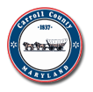
Our chapter needs donations for a "Carroll County-Themed Basket,” which will be auctioned at the Alpha Beta State Convention in April. The money raised from the silent auction will be divided between the DKG International Emergency Fund and the ABS available fund. Some ideal donations are wine from local wineries, jellies, sauces, and any other products manufactured in Carroll County. Wine and beer glasses from county festivals would also be perfect donations. We hope that our sisters are willing to solicit donations, such as discounts and coupons, from county merchants. Requests for donations will be made at the February meeting. Any ideas or contributions should be sent to Laurette O’Keefe at ldokeefe@outlook.com or the following address:
Laurette O’Keefe
2005 Advisory Court
Sykesville, Maryland 21784
Taneytown Elementary School Partnership Update
by Laura McClelland
Many thanks to everyone who donated items for Taneytown Elementary’s 2nd annual Holiday Gift Shop. For those of us who worked at the tables where the items were being sold, we saw first-hand how much the students enjoyed the opportunity to purchase fun and meaningful gifts inexpensively for their family and pets. Students came with the list of family members for whom they were shopping. They got excited when they found just the right item for that special someone. Their gifts were also wrapped and labeled so they were ready to be delivered. We received a lovely note of appreciation from the PTO president and PBIS Support Room Assistants: (on page 4)

Omicron News Page 4 Spring 2019
Dear Ladies of the Omicron Chapter, Delta Kappa Gamma:
Taneytown Elementary School along with the Taneytown Elementary PTO would like to thank you for volunteering and your generous donation to our 2nd Annual Holiday Gift Shop that occurred this past December. The event was AMAZING and your generous donation allowed us an opportunity to bring smiles to our students’ faces and helped us get closer to our fundraiser goals for our PTO and PBIS (Positive Behavioral Interventions and Supports) programs.
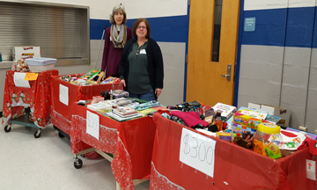
Thank you for your support,

Michelle O. Campbell
(PTO President)
Donna Coale
(PBIS Support Room Assistant)
Michele Stonesifer
(PBIS Support Room Assistant)

There will be two other opportunities for us to support our partnership with Taneytown Elementary. Volunteers will be needed for the school book fair the week of April 1-April 5th and the flower sale in May. Look for emails as we get closer to those dates with the specific needs. Until then, take a few minutes to do the online volunteer training on the CCPS website. Please list the schools in which you want to volunteer.
Also, half of the cookies you bring to the February meeting will be delivered the next morning for the staff to enjoy. Thank you for all you are doing to make this partnership possible.
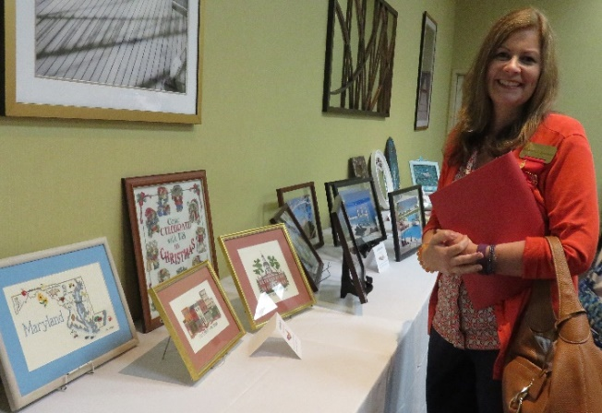
The ABS Convention is in April!
Please plan to attend the Alpha Beta State Convention, April 26, 27, 28. The Hunt Valley location is quite convenient and there’ll be lots to do, see and learn, especially on Saturday when ABS hosts a birthday luncheon, workshops, and the president’s banquet. Come meet your sisters from all over Maryland and hear our keynote speaker, Dr. Donna Niday, the DKG Northwest Regional Director. Show off your artistic talent in the Women in the Arts exhibit and come and view the wonderful handiwork and arts on display at the convention. Let’s have fun with a large Omicron chapter member representation at the convention. Our budget has allowed for ten chapter ambassadors to be reimbursed $20 each for attending. More on that during our February meeting. To register, download the attached registration form. To submit an entry for the women in the arts display, download the exhibit form which is also attached to this newsletter.
Omicron News Page 5 Spring 2019
Recollections of Omicron in the Mid-1960’s
by Althea Miller
When I became a member of Delta Kappa Gamma on November 12, 1966, I would estimate there were 30 members in our chapter (not fact checked). The Omicron chapter was chartered six years earlier in 1960. Prior to that year, three counties (Washington, Frederick and Carroll) were all part of the Gamma chapter. Pi, Gamma and Omicron became three chapters. Unfortunately, I believe Gamma which was in Frederick County has folded.
The chapter’s yearbook from 1964-1966 indicates that dues in the mid 60’s were $8.00 with a 50 cent penalty if not paid by December 1.
Attendance was mandatory for at least half of the meetings. When an absence was necessary, one had to send an explanation (permission slip!) to the recording secretary so it was recorded as an excused or an unexcused absence. If one was delinquent in attendance, she was subject to being dropped.
Meetings were held in churches, schools and the Brethren Service Center, etc. Saturday meetings were held each year with lunch. I think I was inducted at a church near New Windsor. The ladies of the church served lunch. We usually had one dinner meeting each year, often at the Brethren Service Center.
Early in my membership we had a picnic with Pi and Gamma to bring the original membership together each year. It moved from county to county. We had teas for several years. Christmas parties/dinners were held in the homes of members. Their spouses and friends were invited to these affairs. I think they might have been covered dish dinners. We had a member (Chrystal Trump?) who was a professor at Goucher. We had meetings there to see her students (dance) perform.
For a year or two the retired teachers provided dinner (covered dish) for the active teachers.
Communication was via snail mail and telephone. The telephone tree was set up so no one (hopefully) had to make long distance calls. As you may know Mount Airy was kind of a “foreign country” - - a toll call to most of the rest of the county. (We could call part of Montgomery, Howard and Frederick Counties toll free!)
Conventions were a lot of fun and work. Elizabeth “Ippie” Peregoy of Manchester was our state (Alpha Beta) president at one time. I had started teaching at Manchester (1957) so I always felt close to that group.
When I joined, I was the lone member from the southern part of the county. Janice Leatherwood joined a couple of years later. The majority of members lived in Manchester and Westminster! To be considered for membership one had to have taught a minimum of five years. It was all very secretive. A new member was visited by a current member to issue the invitation, tell about the organization and answer questions. (This was after one was voted into membership.)
Omicron News Page 6 Spring 2019
At one time it was very difficult to secure presidents. Members would accept the position of 1st and 2nd vice president but for some reason were unable/unwilling to take the presidency. I’m so happy that has changed! It is so important to move through the ranks, I think.
I remember when Stella Letras was the recipient of the Omicron scholarship/grant-in-aid.
During the second year of my presidency our chapter was one of four (I think) chapters to host the convention. It was an annual event at that time. It was held at Deep Creek. I was able to attend all the planning sessions but unable to attend the convention because I had just had a baby. That was rather unusual because most of the participants were older!
I hope that you enjoyed my stroll down Memory Lane.

DKG Membership Recruitment Plan
Delta Kappa Gamma has rolled out a recruitment plan which is similar to how our membership chair, Laura McClelland, handles recruitment, but with the addition of DKG Prospect Cards. Please open the attached page of “cards,” print them out, make copies and complete them with the names of outstanding educators who you believe would be great members of our chapter. Mail or hand deliver the cards to Laura and she’ll do the rest, i.e. invite the prospective members to a future chapter meeting and give the prospective members orientation. If you need some incentive or encouragement for filling out the cards, below is a way to consider using them for the remainder of the school year:
Feb. 4-8 National School Counseling Week: Recommend a school counselor for membership
March: Youth Art Month: Recommend an Art teacher for membership
March 4-10 National Foreign Language Week: Recommend a foreign language teacher for membership
April: School Library Month: Recommend a media specialist for membership
April 8-12: Assistant Principals Week: Recommend an assistant principal for membership
May 1-7: National Physical Education Week: Recommend a PE teacher for membership
May 6-10: National Teacher Appreciation Week: Recommend an outstanding teacher/colleague for membership.

Omicron News Page 7 Spring 2019
Reminders:

New dues deadline: Dues will be due by June 30th beginning this year. This is a result of changes to the DKG, International by-laws by revamping the dues structure to conform with the end of the fiscal year.

The deadline to attend the ABS March 2nd Executive Board Meeting is February 15th. If you need a registration form, email Iris Wingert @ iwingert3@comcast.net

March 27: Carroll County Chamber of Commerce Outstanding Teacher Awards Ceremony, 6:00 p.m. at WMHS

May 1st is the next deadline to apply for an ABS Professional Growth Mini-Grant of up to $200.

May 1st is also Application Deadline for the Lucile Cornetet Individual Professional Development Award through DKG, International.

Keep up-to-date on chapter activities by visiting the Omicron chapter website at http://omicrondkgmd.weebly.com

There are numerous member benefits from Delta Kappa Gamma, International. Visit http://dkg.org to learn more about them. Also, please update your email address on the DKG online profile by going to My DKG and then to My Account. Click on the pencil above the phone number to make changes. You can also update your address and change your password on this screen. Stay up to date with everything DKG digital!
_ _ _ _ _ _ _ _ _ _ _ _ _ _ _ _ _ _ _ _ _ _ _ _ _ _ _ _ _ _ _ _ _ _ _ _ _ _ _ _ __ _ _ _ _ _ _ _ _ _
May Meeting Dinner Reservation Form

Dinner Meeting at Carroll County Career and Tech Center Wednesday, May 8 at 6 p.m.
Send $15.00 to Stella by Wednesday, May 1 or bring to the April meeting.

Name: __________________________________________________________

Number of people attending: __________ Amount enclosed: $_______________
Make check payable to: Delta Kappa Gamma; Omicron Chapter
Mail to: Stella Letras; 2128 Herbert Ave.; Westminster, MD 21157

